**Typical Example**

**Horizontal Alignment (length = 40.274)**

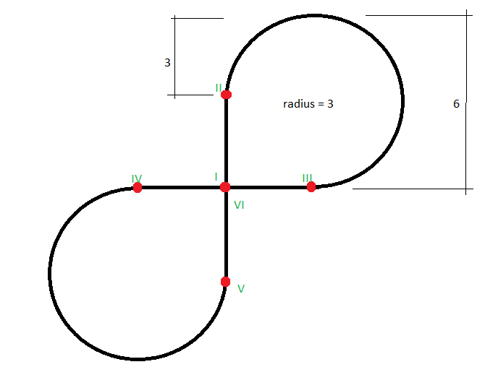

Segment 1 (I -> II)

LINE, direction up, length = 3.

Segment 2 (II -> III)

CIRCULARARC, clockwise, radius = 3, 270 degrees (length = 14.137)

Segment 3 (III -> IV)

LINE, direction left, length = 6.

Segment 4 (IV -> V)

CIRCULARARC, anti-clockwise, radius = 3, 270 degrees (length = 14.137)

Segment 5 (V -> VI)

LINE, direction up, length = 3.

Segment 6 (VI)

LINE, direction up, length = 0.

**Vertical Alignment (offset = 3 + 1.25 * radius * Pi, length = 6 + radius * Pi / 2)**

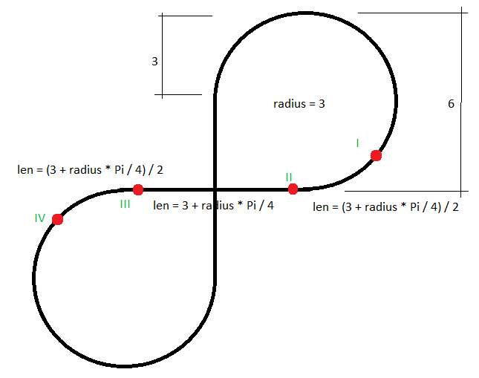

Segment 1 (I -> II)

CIRCULARARC, start gradient 0, end gradient 0.7, length = 2.678. (Derived: radius = 4.67, anti-clockwise)

Segment 2 (II -> III)

CIRCULARARC, start gradient 0, end gradient 0.7, length = 5.356. (Derived: radius = 4.67, clockwise)

Segment 3 (III -> IV)

CIRCULARARC, start gradient 0, end gradient 0.7, length = 2.678. (Derived: radius = 4.67, anti-clockwise)

Segment 4 (IV)

CONSTANTGRADIENT, direction right, length = 0.

**Cant Alignment (length = 40.274)**

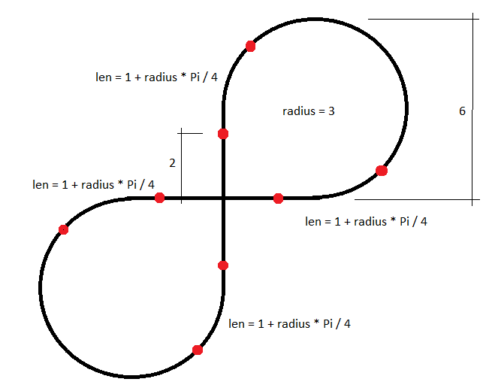

Segment 1 (I -> II)

CONSTANTCANT, direction right, length = 2.

Segment 2 (II -> III)

LINEARTRANSITION, horizontal length = 3.35619449019 (1 + radius * Pi / 4), direction right-up.

Segment 3 (III -> IV)

CONSTANTCANT, direction right, length = 9.42477796077 (i.e. radius * Pi).

Segment 4 (IV -> V)

LINEARTRANSITION, horizontal length = 3.35619449019 (1 + radius * Pi / 4), direction right-down.

Segment 5 (V -> VI)

CONSTANTCANT, direction right, length = 4.

Segment 6 (V -> VI)

LINEARTRANSITION, horizontal length = 3.35619449019 (1 + radius * Pi / 4), direction right-up.

Segment 7 (V -> VI)

CONSTANTCANT, direction right, length = 9.42477796077 (i.e. radius * Pi).

Segment 8 (V -> VI)

LINEARTRANSITION, horizontal length = 3.35619449019 (1 + radius * Pi / 4), direction right-down.

Segment 9 (V -> VI)

CONSTANTCANT, direction right, length = 2.

Segment 10 (VI)

CONSTANTCANT, direction right, length = 0.

Important note (generic):

***At each start of a segment the rotation is defined by a difference in StartCantLeft and StartCantRight in combination with half the value of the IfcAlignmentCant.RailHeadDistance.***

***In the geometry this rotation is stored as third dimension of the IfcCurveSegment.Placement definition.***